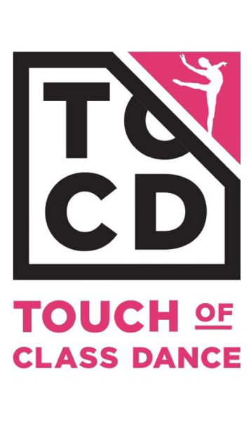

DANCERTAINERS 2018

Would you like to use your dance talent to give back to the community? Or be in the big finale of TOCD’s top notch recital?
If so, it is time for you to join our DANCERTAINER PROGRAM
Touch of Class would like to extend to you an invitation to our professional Community Service based, non-profit, traveling group, the Dancertainers.

Who are the Dancertainers?

The Dancertainer traveling dance troupe embodies the heart and soul of the Touch of Class Organization. Made up of 100 or more voluntary members, this performance group donates their time and enthusiasm to those less fortunate and those who appreciate wholesome entertainment.

Dancertainers originated in 1988 as a way for Touch of Class to give back to the local community and to provide costless access to the arts. What began as a small group of students dancing at retirement homes and hospitals has now blossomed into a full scale musical production. From original songs and amazing scripts to quality choreography and dance, the program has grown to one of the largest studio based, volunteer dance ensembles in the tri-state area.

The Touch of Class Dancertainers now entertains during the Holiday Season at nursing homes, at tree lighting ceremonies and parades, as guests in professional holiday venues, at local schools, at breakfasts with Santa, at Girl Scout socials, and in the Spring as the finale of the TOC recital.

In addition to providing the Delaware and Chester counties with hours of memorable dance programming, the Dancertainer program allows students to enjoy increased performance experience and community exposure. It also affords them the opportunity to receive community service recognition for their work. Dancertainers provides ALL students, regardless of age or ability, to do what they love most -dance for others. This program truly touches the spirit of both those that participate and those that view its production.

WHAT ARE THE REQUIREMENTS TO BECOME A DANCERTAINER?

- You must registered in Prep Ballet/Tap or above and attend rehearsals on the below dates:

- Broomall Dancertainers beginning: Sunday, October 7th
- Broomall Group rehearsals held SUNDAY 10/7, 10/14, 10/28, 11/4 from 12 to 2 pm
DRESS REHEARSAL FOR BROOMALL:
_________________________________________________________________________________________
- Downingtown Dancertainers beginning: Saturday, October 6th
- Downingtown Group rehearsals held SATURDAY 10/6, 10/13, 10/27, 11/3 from 12:30– 2:30 pm
DRESS REHEARSAL FOR DOWNINGTOWN: SATURDAY, NOVEMBER 10TH - BROOMALL LOCATION FROM 1:30 to 3:30 PM

WHAT DO I NEED TO COMMIT TO:

- Commit to the tour schedule which usually takes place during weekends in November and December (Up to December 9th) and the Holiday Season. This tour schedule will be announced in October.

- Fall Fundraising– JOE CORBIS - 1 child participating must meet the $200 quota or pay $100 opt out. Families participating must meet the $300 quota or pay $150 opt out. Fundraising Forms due Monday, 11/5.
All PROFIT ONLY money made out to the TOCPO will be due by 11/1 to your studio location.

- All students will need to purchase a NEW TOCD Track Jacket via this online website:
Jackets can be purchased at the following webstore link: LINK ACTIVE FROM THE PRESENT to SEPTEMBER 15th.
https://bandesportswear.com/index.php?route=product/category&path=136

****All TOCD JACKETS MUST BE PURCHASED BY 9/15/18 – LINK WILL GO INACTIVE AFTER THIS DATE

WHAT IS THE DEADLINE TO APPLY FOR DANCERTAINERS?

- All TOCD Dancers interested in joining the 2018 Dancertainer Program must visit www.touchofclassdance.com and register ONLINE for the TOCD DANCERTAINER EVENT. There is NO FEE for this event. Please make sure you select the PROPER STUDIO LOCATION for your Dancertainer Event.
All REGISTRATION must be COMPLETED ONLINE by SATURDAY, SEPTEMBER 15th

